

**American International University- Bangladesh**

**CSC 3215: Web Technologies**

**CO2 and CO4 Evaluation**

**Finished Project Report**

**Summer 2020-2021**

# **Project Title: Hotel Management System**

**Section: D**

|  |  |
| --- | --- |
| Student Name | Student Id |
| AHMED, ZUBAIR | **19-39745-1** |
| KANTA,KANIZ FATEMA | **19-40788-2** |
| RAHMAN,SHAFIUR | **19-40770-2** |
| SHIUM, SHEIKH MAHMUDUL HASAN | **19-40764-2** |

# Hotel Management System

Our Project is about a management system in a hotel. There are 5 panels which are, Customer Panel, Admin Panel, Manager Panel, Receptionist Panel and a Head-Chef Panel. All of them have to login to proceed to the panels.

In the Customer Panel the customers will have a customer profile and a customer id. The customers will be able to see the rooms with prices, room categories, upcoming events and book them through online. They will also have the facility of online payments. If the customers have checked in then they will have the facility to order food, reserve schedule for gym and spa. The customers can leave a rating and review. They can ask questions. The customers will be very much helpful using the website.

In the Admin Panel the admin will be able to manipulate the rooms, room categories, events, employees. Admin will have the ability to add, edit and remove the rooms, room categories, events and employees. He can change the names, times, descriptions and many more. He will be able see the booked rooms and booked events. He can also see the reserved gym and spa schedule. The admin will answer the customers questions and give notice.

In the Manager Panel the manager will have almost the same abilities. The only difference is the manager won’t be able to manipulate the employees. Except that all his features are same as the Admins.

In the Receptionist panel the receptionist will be able to check in and check out the customers, book rooms for the customers. He will be able to see the booked rooms and the available rooms.

Overall there will be a homepage where there will information about the hotel and contact information. There will be a gallery which will be full of photos of the hotel. There will be a notice section where the customers will be able to see the notices about events, offers and many more. The application will be very much helpful for the customers and the employees.

**Project Folder Structure:**

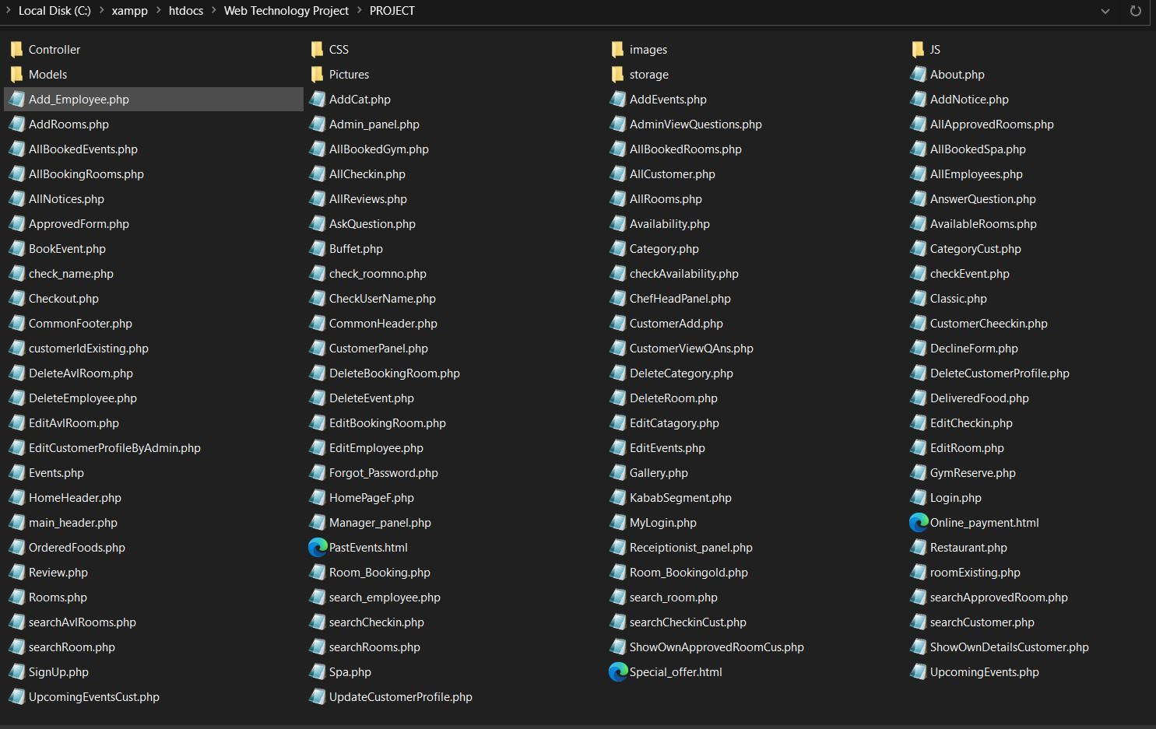

**Core Modules of the Project:**

**Login.php**

<?php require_once 'Controller/LoginController.php';?>

<html>

<script src="JS/login.js"></script>

<body>

<fieldset>

<form action="" onsubmit="return validate()" method="post">

<table align="center">

<tr>

<td colspan="2" align="center"><h2 style="color:blue"><b>InterContinental Residence <br> Suites</b></h2></td>

</tr>

<tr>

<td colspan="2" align="center"><img width="200px" heigth="100px" src="Pictures/Resturant pic.jpg"/>

</td>

</tr>

<tr>

<td align="center"><input id="uname" name="Username" placeholder="Username" value="<?php echo $Username;?>" type="text"> <br> <span id="err_uname"><?php echo $err_Username;?></span></td>

</tr>

<tr>

<td align="center"><input id="pass" name="Password" placeholder="Password" value="<?php echo $Password;?>" type="Password"> <br> <span id="err_pass"><?php echo $err_Password;?></span> </td>

</tr>

<tr>

<td colspan="2" align="center"><a href ="Forgot_Password.html">Forgot password?</a></td>

</tr>

<tr>

<td colspan="2" align="center"><a href ="Admin_panel.php"><input name="Log_In" type="submit" value="Log In">

</td>

</tr>

</table >

</form>

</fieldset>

</body>

</html>

**Rooms.php**

<?php

if(!isset($_COOKIE["loggeduser"]) && !isset($_COOKIE["loggeduser1"]) ){

header("Location: Login.php");

}

?>

<?php

require_once 'Controller/RoomsController.php';

require_once 'main_header.php';

$rooms = getRooms();

setcookie("ROOMS","ROOMS",time()+(500));

echo "<h1 align='center' style='color:green'> All ".$_COOKIE["ROOMS"]."</h1>";

$i=1;

echo "<h3 align='center' style='color:brown'>

Search Rooms: <input type='text' onkeyup='searchRooms(this)'><div id='suggesstion'></div><br>";

//echo "&nbsp;&nbsp;";

foreach($rooms as $c)

{

$id = $c["id"];

echo "<table align='center' style='width:50%; height:30%;' border = '4'>";

echo "<tr><td>ID</td><td>Room No.</td><td>Catergory</td><td>Price</td>";

echo "<tr>";

echo "<td>$i.</td>";

echo '<td>'.'<b>'.$c["room_no"].'</b>'.'</td>';

echo '<td>'.'<b>'.$c["c_name"].'</b>'.'</td>';

echo "<td>".'<b>'.$c["c_price"].'</b>'.' BDT'."</td>";

/* echo "<td>".$c["qty"]."</td>";

echo "<td>".$c["desc"]."</td>"; */

echo '<td>&nbsp;&nbsp;&nbsp;<a href= "EditRoom.php?id='.$c["id"].'"><input type="button" value="Update"> </a> &nbsp;&nbsp;&nbsp;

<a href= "DeleteRoom.php?id='.$c["id"].'"><input type="button" value="Delete"> </a></td>';

echo "</tr>";

$i++;

echo "</table>";

echo '&nbsp;';

}

?>

<script src ="JS/searchRooms.js"></script>

**Room_Booking.php**

<?php

require_once 'Controller/BookingRoomController.php';

?>

<html>

<body>

<fieldset>

<form action="" onsubmit= "return validate()" method = "post">

<table style="border-color:green; width:40%; height:50%;" align="center" border="4">

<tr>

<td align="center" colspan="2"><h1 >Room Booking</h1></td>

</tr>

<tr>

<td align="center" colspan="2"><img width="300px" heigth="200px" src="images/Room.jpg"/></td>

</tr>

<tr>

<td align="left"><b>Room No:</b></td>

<td><input id="RoomNo" name="RoomNo" onfocusout="checkRoom(this)" value="<?php echo $RoomNo;?>" type="text">

<br><span id="err_RoomNo" class="text-danger"><?php echo $err_RoomNo; ?></span>

</td>

</tr>

<tr>

<td align="left"><b>Username:</b></td>

<td><input id="uname" name="userName" value="<?php echo $userName;?>" type="text">

<br><span id="err_uname" class="text-danger"><?php echo $err_userName; ?></span>

</td>

</tr>

<tr>

<td align="left"><b>Branch:</b></td>

<td>

<select id="Branch" name="Branch" value="<?php echo $Branch;?>">

<option selected disabled>--select--</option>

<?php

foreach($Br as $b)

{

if($b == $Branch)

echo "<option selected>$b</option>";

else

echo "<option>$b</option>";

}

?>

</select>

<span id="err_Branch">&nbsp; <br><?php echo $err_Branch; ?></span>

</td>

</tr>

<tr>

<td align="left"><b>NID:</b></td>

<td><input id="NID" name="NID" value="<?php echo $NID;?>" type="text">

<span id="err_NID">&nbsp; <br><?php echo $err_NID; ?></span>

</td>

</tr>

<tr>

<td align="left"><b>Address: </b></td>

<td><input id="Address" name="Address" value="<?php echo $Address;?>" type="text">

<span id="err_Address">&nbsp; <br><?php echo $err_Address; ?></span>

</td>

</tr>

<tr>

<td align="left"><b>Email: </b></td>

<td><input id="Email" name="Email" value="<?php echo $Email;?>" type="text">

<span id="err_Email">&nbsp; <br><?php echo $err_Email; ?></span>

</td>

</tr>

<tr>

<td align="left"><b>Phone no: </b></td>

<td><input id="Phone" name="Phone" value="<?php echo $Phone;?>" type="text">

<span id="err_Phone">&nbsp; <br><?php echo $err_Phone; ?></span>

</td>

</tr>

<tr>

<td align="left"><b>Check in time: </b><br> (dd-mm-yyyy)</td>

<td><input id="CIT" name="CIT" value="<?php echo $CIT;?>" type="text">

<span id="err_CIT">&nbsp; <br><?php echo $err_CIT; ?></span>

</td>

</tr>

<tr>

<td align="left"><b>Check out time: </b><br> (dd-mm-yyyy)</td>

<td><input id="COT" name="COT" value="<?php echo $COT;?>" type="text">

<span id="err_COT">&nbsp; <br><?php echo $err_COT; ?></span>

</td>

</tr>

<tr>

<td align="center" colspan="2"><input name="Room_Booking" type="submit" value="Book Now"></td>

</td>

</tr>

</table>

</form>

<script src="JS/Room_Booking.js"></script>

<script src="JS/Rm_bk.js"></script>

</fieldset>

</body>

</html>

**Database Schema:**

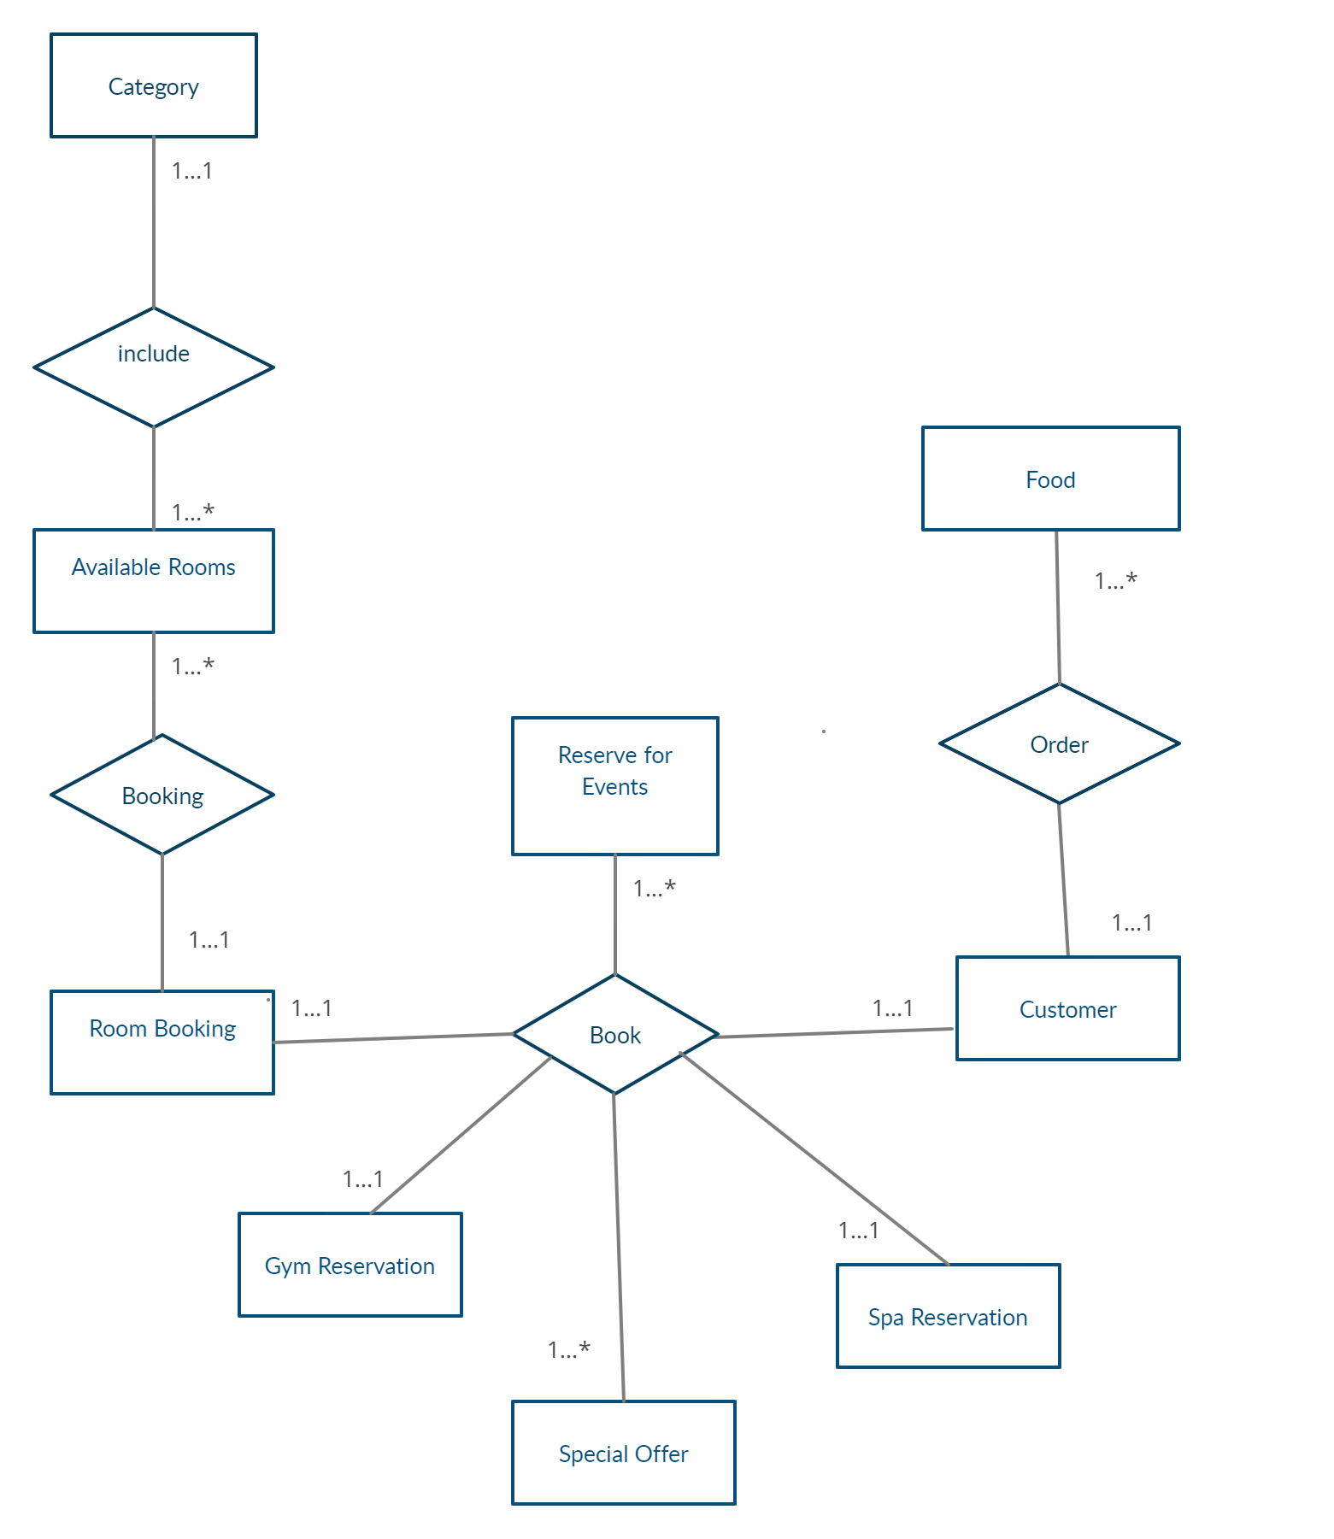

|  |  |  |  |  |  |
| --- | --- | --- | --- | --- | --- |
| **CO2 and CO4 Evaluation: Project Report Evaluation** | | | | | |
| **Completeness**  **(5)** | **Validation**  **(5)** | **Feature Implementation**  **(5)** | **Concept Understanding**  **(5)** | **Promptness (5)** | **Total (25)** |
|  |  |  |  |  |  |
|  | | | | | |